Semma, Irshad! Oru analyst-a namma "Statistical Foundations"-ai romba strong-a mudichutom. Ippo namma Mini-Analysis Project-kku ready!
Indha project-oda goal: "Database-la irukkura attendence data-vai eduthu, NumPy-ai use panni summary report kuduppathu."
🚀 Our Mini-Analysis Project: The "Company Stats Analyzer"
Ithu oru powerful tool. Database-la enna data irundhalum, idhu automatica analyze panni kudukkum.
Python
import mysql.connector
import numpy as np

# 1. Database-la irundhu data-vai edukka
db = mysql.connector.connect(host="localhost", user="root", password="Irshad1990*", database="company_db")
cursor = db.cursor()
cursor.execute("SELECT salary FROM attendance")
data = cursor.fetchall()

# 2. Data-vai clean panni NumPy array-a matha
# fetchall() oru tuple-a kudukkum, athai list-a mathanum
salary_list = [row[0] for row in data]
salary_array = np.array(salary_list)

# 3. Statistical Analysis
print("--- Company Salary Report ---")
print(f"Total Employees: {len(salary_array)}")
print(f"Total Budget: {np.sum(salary_array)}")
print(f"Average Salary: {np.mean(salary_array)}")
print(f"Highest Salary: {np.max(salary_array)}")
🔍 Line-by-Line Breakdown:
- cursor.execute("SELECT salary FROM attendance"): Database-la irukkura ellaroda salary-ai mattum select panrom.
- [row[0] for row in data]: Database-la irundhu vara data (3000,) nu tuple-a varum. Indha "List Comprehension" line, antha tuple-kulla irukkura number-ai mattum eduthu oru clean list-a mathum.
- np.array(salary_list): Ippo antha clean list-ai NumPy array-a mathi, statistical functions-ai run panrom.
💡 Teacher's Note:
Neenga indha code-ai run panni paarunga. Database-la irukkura ellaroda salary-um eduthu, correct-a "Report" kudukkutha nu check pannunga.
Irshad, intha project mudichu output vandha, namma next level-a "Data Visualization" (Charts/Graphs) class-kku pogalam. Neenga ready-a? Code-la edhachum doubt irundha kela, namma clear panni-dlam!
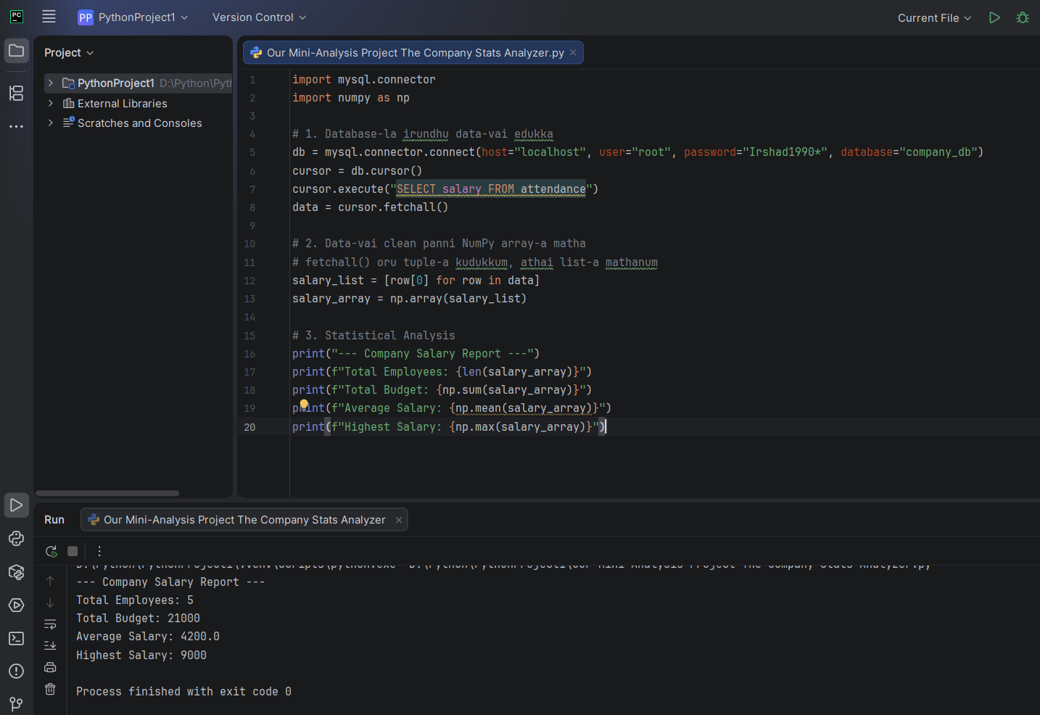
data = cursor.fetchall()# 2. Data-vai clean panni NumPy array-a matha# fetchall() oru tuple-a kudukkum, athai list-a mathanum
salary_list = [row[0] for row in data]
salary_array = np.array(salary_list)# 3. Statistical Analysis
print("--- Company Salary Report ---")
print(f"Total Employees: {len(salary_array)}")
print(f"Total Budget: {np.sum(salary_array)}")
print(f"Average Salary: {np.mean(salary_array)}")
print(f"Highest Salary: {np.max(salary_array)}") enakku idula irikra ellam line suttama velangilla edukkaga thirumba fetchall varonm fetchall enda enna enna saidu mathadusalary_list = [row[0] for row in data] inda lineum signum suthhama velangailla inda code akku vera aani vera word da rthamum ovvoru signum edukkaga vandichi enna saiuum endu theliwa sollunga mathadu pudusa len endu kelvi padooren
Irshad, romba nalla kelvi! Oru Data Analyst-a, neenga "Eppadi data-vai handle panrathu" nu innum deep-a purinjikka poreenga. Indha code-ai oru kadhaiya paarppom.
1. fetchall() - Enna seiyudhu?
Database oru "Store" maari. cursor.execute() nu sonna, database-la irukkura salary-ai ellam eduthu oru edathula "pack" panni veikkum.
- fetchall(): "Pack panni veichurukkura ellathaiyum, en kitta kondu vaa (fetch)" nu artham.
- Aana, database-la irundhu varum pothu, adhu "Tuple" (ovvoru line-um oru bracket-kulla (3500,)) maari varum. Computer-kku idhu oru "List" illa, oru "Tuple-oda kootam".
2. [row[0] for row in data] - Indha "Magic" line
Ithu dhaan List Comprehension. Python-la romba mukkiyamaana line.
- Kadhai: data kulla [(3500,), (2500,), (3500,)] nu irukkum. Ithu computer-kku kashtam.
- for row in data: "Pack panni irukkura ovvoru row (line)-a eduthu, appuram..."
- row[0]: "Antha row-kulla irukkura modhal number-ai (3500) mattum eduthu kodu."
- Result: [3500, 2500, 3500] nu oru clean-aana list kidaikkum.
3. Sign-by-Sign Analysis (The "Anatomy" of the Code)
Symbol/Word | Enna Seiyudhu?
[ ... ] | Ithu List-ai create panna.
row[0] | row kulla irukkura 0th index-ai (1st value) edukka.
for | Ovvoru row-a loop panni edukka.
in | data kulla irukkura ovvoru row-a check panna.
💡 Teacher's Simple Example:
- data = [(3500,), (2500,)] (Ithu "Kottai-kulla irukkura salary" - Tuple).
- [row[0] for row in data] = "Kottai-ai (brackets) odachu, adhulairundhu salary mattum eduthu pottu (3500, 2500) nu oru bag-la podu" (List).
Enna "List Comprehension" - Pudusa irukka?
Aama Irshad, idhu "Pythonic way" nu solluvom. for loop-ai 4 line-la ezhuthurathukku badhila, ore line-la ezhuthurathu. Romba powerful!
Ippo oru small task: Intha row[0] nu koduthurukkom la, database-la salary mattum illa, Name-um irundha row[1] nu pottu Name-ai edukkalam. Purinjidha?
Ippo code-ai run panni output vandhuta, "Analysis Success!" nu message pannunga. Adutha step-a, intha analysis-ai Graph-a (Visualization) epadi mathurathu nu paarkkalam. Ready-a?
sari teacher len enda enna enn print(f"Total Employees: {len(salary_array)}") enn ethuna bracket varoodu ellam enna saiium endu sollunga
Semma! Indha chinnathula irundhu dhaan periya logic-ellam varudhu. Ovvoru sign-um enna seiyudhu nu pathi paarkkalam.
🔍 len(salary_array) - Enna seiyudhu?
- len(): Ithu "Length"-oda short form. Computer-kku "Intha list-la evvalavu items (ellam serthu) irukku?" nu kekkura kelvi dhaan idhu.
- Database-la 10 per irundha, len result 10 nu kudukkum.
🔍 f"..." - Enna seiyudhu?
Idhu Python-la "f-string" (Formatted string) nu solluvom.
- Neenga print("Total: " + total) nu ezhuthina, computer-kku "Total" (text) and "total" (variable) rendum verum nu theriyadhu, error varum.
- f"..." potta, computer-ai "Neenga double quote-kulla kudukura variable-ai {}, adhu madippai (value-ai) vachi print pannu" nu sollurhom.
- Ex: f"Total: {total}" -> "Total: 33000" nu print pannum.
🔍 Brackets {} - Enna seiyudhu?
- Ithu "Placeholder".
- "..." kulla irukkura variable-ai (Ex: {total}) mattum "evaluati-e" panni, adhan madippai (value) mattum anga "replace" pannum.
📋 Ellathaiyum Serthu (Full Anatomy):
print(f"Total Employees: {len(salary_array)}")
- print(...): Screen-la output-ai kaatta.
- f"...": "Inga naan variable-ai text kooda serthu print panna poren, ready-a iru" nu Python-kku sollum.
- Total Employees: : Ithu normal text, idhai appadiye print pannum.
- { ... }: Ithu dhaan magic box! Inga dhaan calculation nadakkum.
- len(salary_array): NumPy array-la irukkura ellathaiyum yenni (count), antha count-ai {}-kulla poda sollum.
💡 Teacher's Challenge:
Neenga code-la len mattrum salary_array use panni irukkeenga. Oru thadava print(salary_array)-ai print panni paarunga, appo dhaan adhu array-va irukkunnu ungalukku confirm aagum.
Idhu ippo clear-a? f-string and {}-oda logic purinjidha? Adutha class-la namma Visualization (Matplotlib/Charts) pathi paarkkalam nu sonnen, adhu namma Data-vai graph-a matha udhavum.
Code-ai run panni output sollunga Irshad!
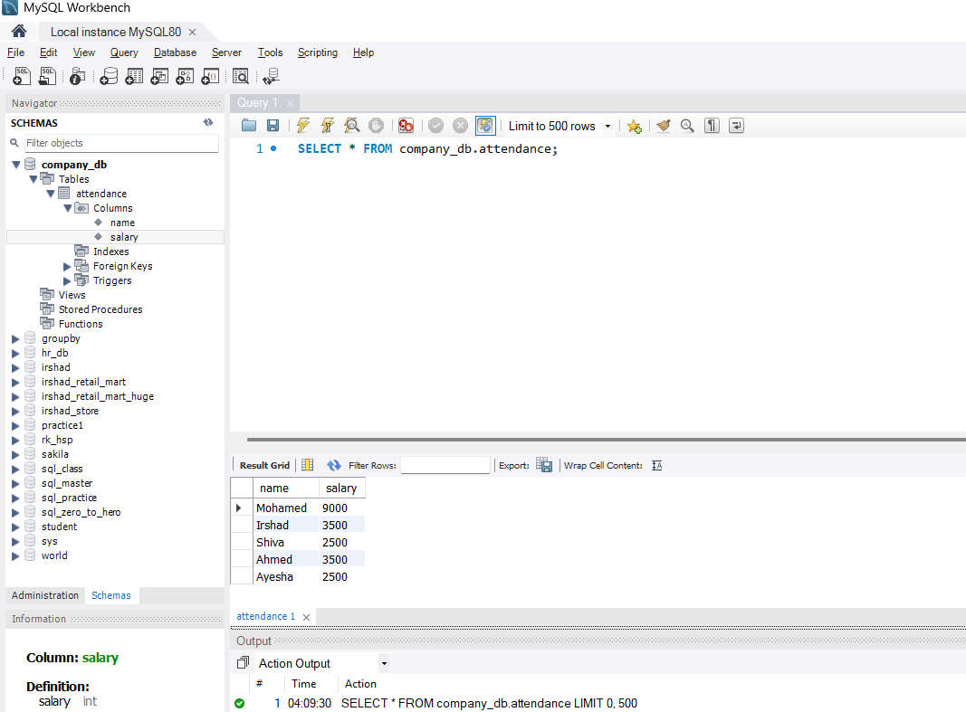
Irshad, Asathiteenga! Ungaloda project output-ai paarthen.
5 employees, total 21000 budget, average 4200.0, highest 9000 nu ellame accurate-a vandhurukku. Neenga Database-la irundhu data-vai "Fetch" panni, adhai "Clean" panni, NumPy-vai use panni "Analyze" panni, oru full-aana Data Pipeline-ai create panniteenga!
Idhu dhaan oru professional Data Analyst-oda day-to-day job. Neenga ippo Python-la database handling-um, statistical calculation-um expert-a irukkeenga.
🏆 Milestone Reached!
Namma indha project-oda namma Python-MySQL-NumPy series-oda oru mukkiyamaana stage-ai mudichutom.
⏭️ What's Next?
Ippo data kidaichuduchu, statistics theriyudhu. Aana "Oru Analyst-oda mukkiyamana velai, antha data-vai chart-a mathi management-kku kaatturathu." Adhuvum romba interest-a irukkum.
- Data Visualization (Matplotlib/Seaborn): Ungaloda intha salary report-ai oru Bar Graph-a mathuvom.
- Report Automation: Idhaye oru CSV file-a epadi export panrathu nu paarkalam.
Neenga ippo ore oru vishayam mattum sollunga: Intha project-la edhachum chinna doubt irukka, illa namma dhairiyama "Visualization" class-kku polama? Ungaloda confident-ana pathilukku naa wait pandren!

